Cisco Switch Port Mirroring

Thursday, May 25, 2023

2:41 PM

# How to Connect a console cable

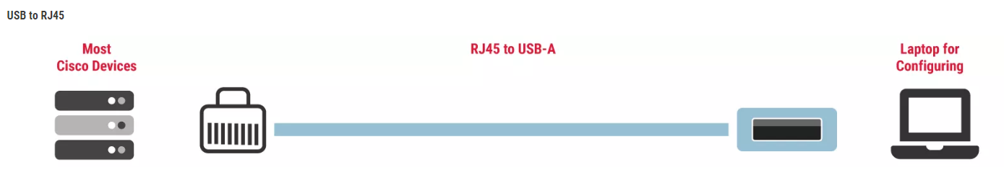

[What Are Console Cables and Why Do I Need Them? (cablesandkits.com)](https://www.cablesandkits.com/learning-center/what-are-console-cables-why-need-them)

# Access Cisco CLI

After connected the console cable from Switch to the computer, open MobaXterm and establish a Serial session.

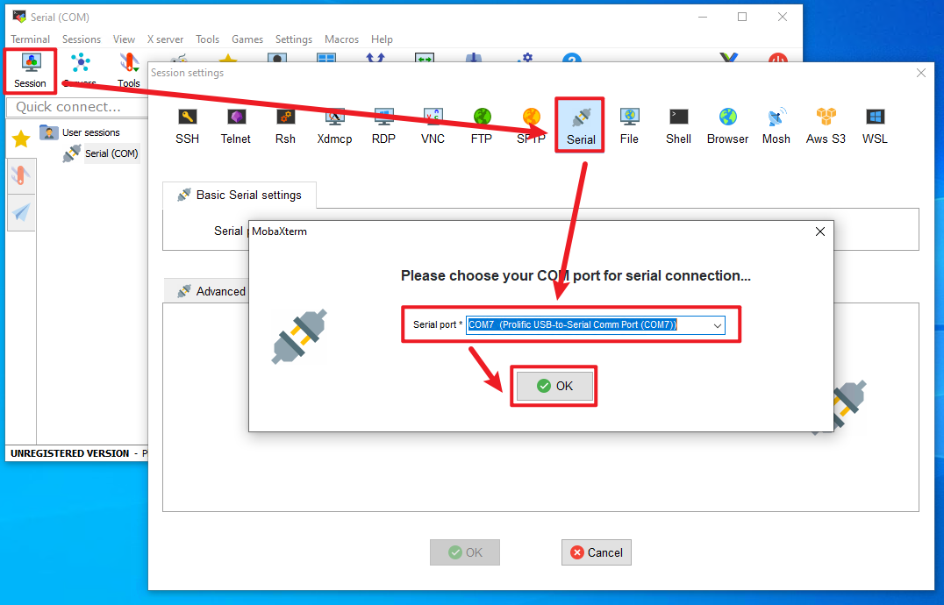

You may see an error message, but we can ignore it.

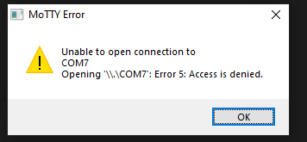

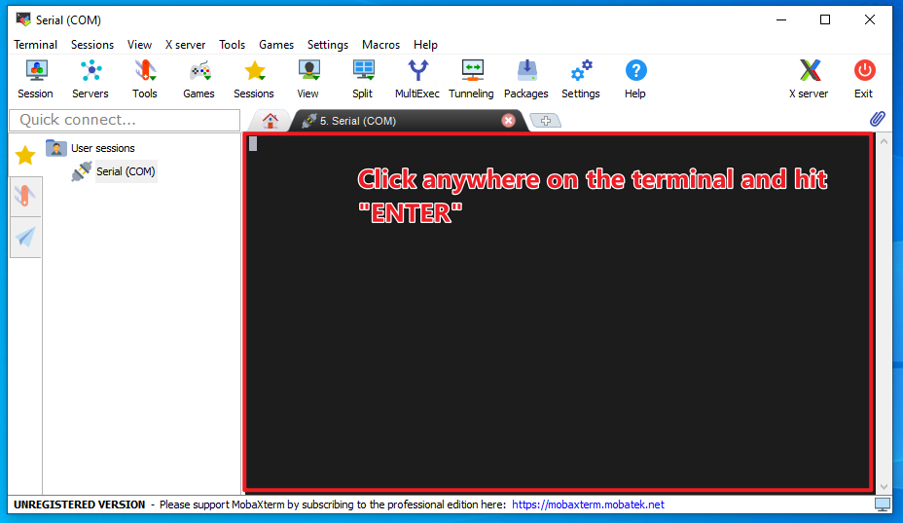

# General Guide (Skip if you know Cisco CLI)

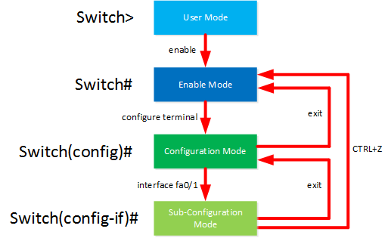

1. Check the above diagram for how to switch across three different modes of cisco devices.
   1. In short, Enable mode allows us to READ settings only, Config mode allows us to WRITE settings only.
   2. In config mode, we can also READ by attaching "do" at the start of the Enable mode command. (Has a few exceptions like "copy run start").
      1. i.e., do show interface (If you see "do”, you know that "show interface" is an enable mode command)
2. You can Use Ctrl+Shift+6 to interrupt most commands.
3. Press "?" at anywhere if you need to see a list of possible commands.

# Now let's Start with exploring the switch port/interface status!

Enter config mode by typing the below: (Those are abbreviations that the CLI can recognize)

en

conf t

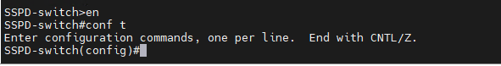

Check all interface status. You may hit SPACE to see more lines. If you want it to stop, press "Ctrl Shift 6" or Right arrow or Ctrl C.

do show interface

We can see that the FastEthernet 0/1 (DarkTrace) and 0/24 (Dell Server) are up.

FYI, the abbreviations for these two ports are: fa0/1 fa0/24

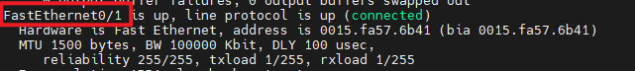



# Configure Port Mirroring (aka. Port Monitoring)

Ref: [How to configure port monitoring (SPAN) on a Catalyst 2940, 2950, 2955, 2970, 3550 or 3750 series sw... - Cisco Community](https://community.cisco.com/t5/networking-knowledge-base/how-to-configure-port-monitoring-span-on-a-catalyst-2940-2950/ta-p/3132032)

[Catalyst Switched Port Analyzer (SPAN) Configuration Example - Cisco](https://www.cisco.com/c/en/us/support/docs/switches/catalyst-6500-series-switches/10570-41.html#anc3)

Check if there is any port mirroring config in the system. For this tutorial, Dell Server will be at the source port being copied its traffic. DarkTrace will be at the destination port receiving the copied traffic. **Your situation may vary.**

do show monitor

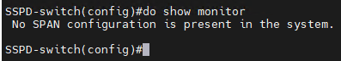

Configure source port for mirroring (Dell Server). This is the device being mirrored its traffic.

monitor session 1 source interface fa0/24

Configure destination port for mirroring (DarkTrace). This is the device that receives the mirrored traffic.

monitor session 1 destination interface fa0/1

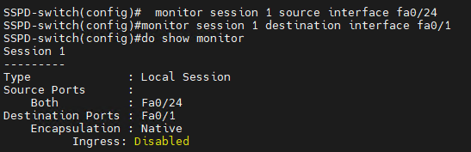

Lastly, we want the two ports to be in default VLAN and have same access mode, use the below to find out:

do show running-config





If you don’t see any setting for this port, this means that fa0/24 is connected to default VLAN, and using default mode.

do show vlan

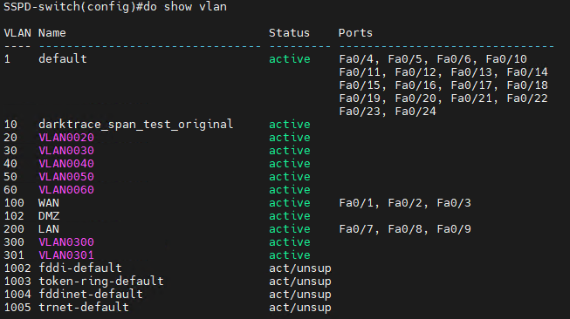

Unfortunately, above screenshots suggest that the Fa0/1 that connects DarkTrace actually belongs to the "WAN" VLAN (id:100)!

We need to change Fa0/1 from WAN to default VLAN. It is not required to be the same as Fa0/24, we just don't want it to be WAN to be safe.

# Configure Switch Port Mode

Make sure you are at the config mode and type the below to enter sub-configuration mode. This allows you to perform interface sub-configurations (config-if):

interface fa0/1

Then please type below code in the screenshot:



We also want fa0/24 to use the "access" mode rather than default mode (dynamic desirable).





# Final Checking

You may run the below to do some **Final Checking** before we apply configuration:

do show vlan (Check VLAN allocation)

do show interface switchport (Check switch port mode)

do show running-config (Check all current settings in RAM)

As shown in "do show running-config" output, they are now both connected to default VLAN, and mode set to access. We can also see our monitoring settings.





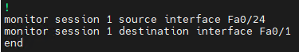

# Saving the Configuration

Exit the config mode into enabled mode.

We must apply the settings by writing the running-config (RAM) to startup-config(ROM). And we must do it in Enable mode only.

Ref: [How to Manage and Save Running Config on Cisco Devices (netwrix.com)](https://blog.netwrix.com/2019/09/10/how-to-manage-and-save-running-config-on-cisco-devices/)

If you are still in config mode, you need to:

exit

copy run start

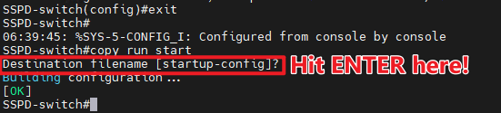

# Validation

Validate on the device that is connected to the destination port of the port monitoring/mirroring session.

Using Packet Sniffer is an alternative.

# Additional Information

## Cisco Enable/Config/Config-if mode Abbreviations

en

conf t/m/n

int fa0/1

## Switch Port Modes for mirroring

For switch port monitoring, the source and destination ports can be in different modes, but there are some considerations to keep in mind:

Source Port:

The source port, from which you want to copy the traffic, can be in either access or trunk mode.

1. In access mode, the port will copy the traffic of another port or specific VLANs.
2. In trunk mode, the port will copy the traffic of multiple VLANs.

Destination Port:

1. The destination port, where you want to send the copied traffic for monitoring, should typically be in access mode.
2. The destination port does not participate in any VLANs but serves as the endpoint for receiving the copied traffic.